Network Task

Task Description:

1.Get me the IP address of a particular domain (guvi.in). How do I find my CPU/memory usage of my server?. Test the connectivity between 2 nodes?
Ping guvi.in
172.67.70.207
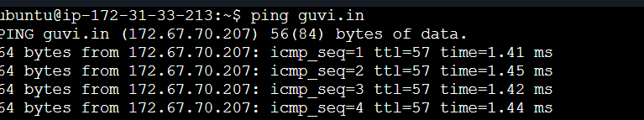
Test connectivity between 2 nodes:
Instance1 Private ip: 172.31.43.175
Instance 2 private ip: 172.31.45.56
Edited inbound rule by allowing the other instance ip with ICMP enabled.
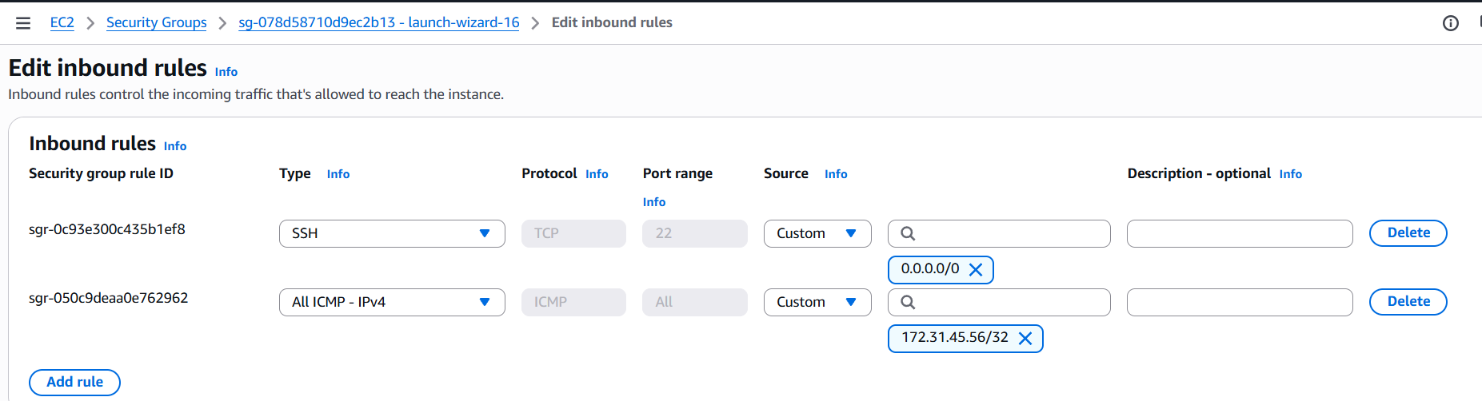

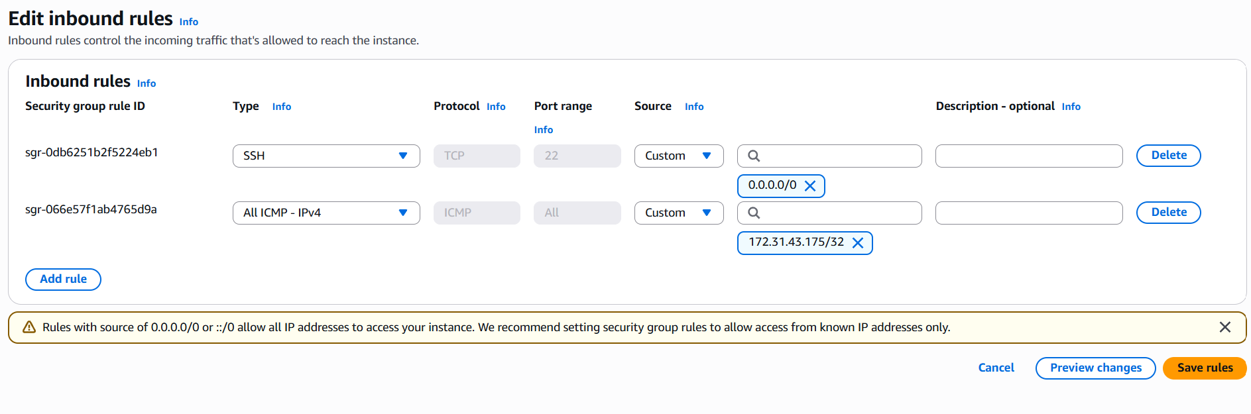

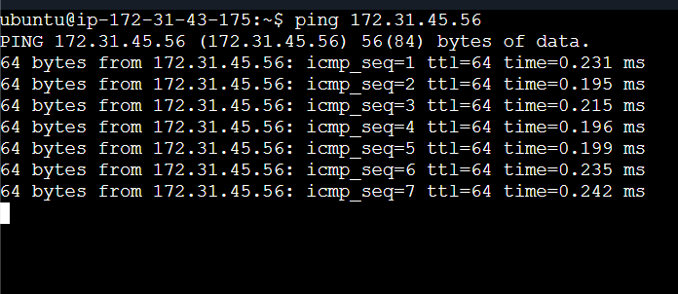

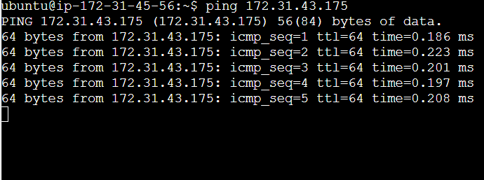

2.I have deployed an application in guvi.com:9000, and logs show my app is running, but I’m unable to view the page. Check whether my port is open or not ?

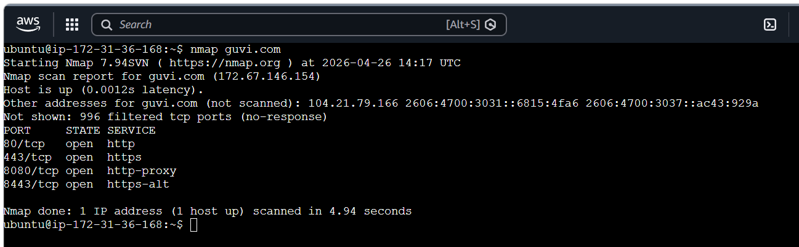
No 9000 port is opened for guvi.com
Only 80,443,8080,8443 is in open state
Nmap -p 9000 guvi.com shows filtered state – which says the environment is very we secured. Not sure whether the port is open or closed.
